LAB TASK-2

Program#1

Practicing with math operators.

CODE INPUT:

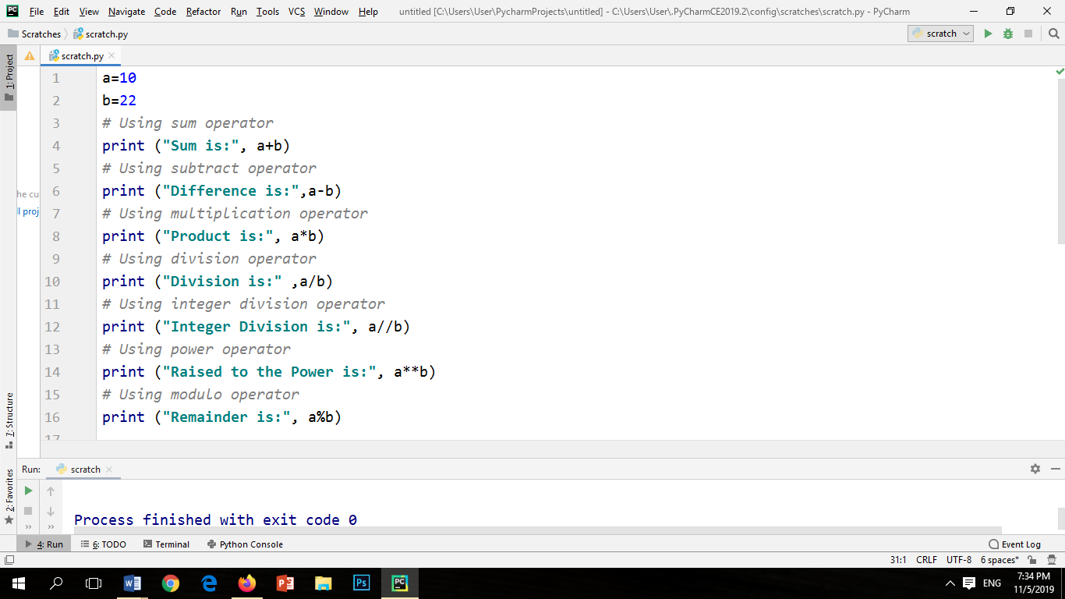

CODE OUTPUT:

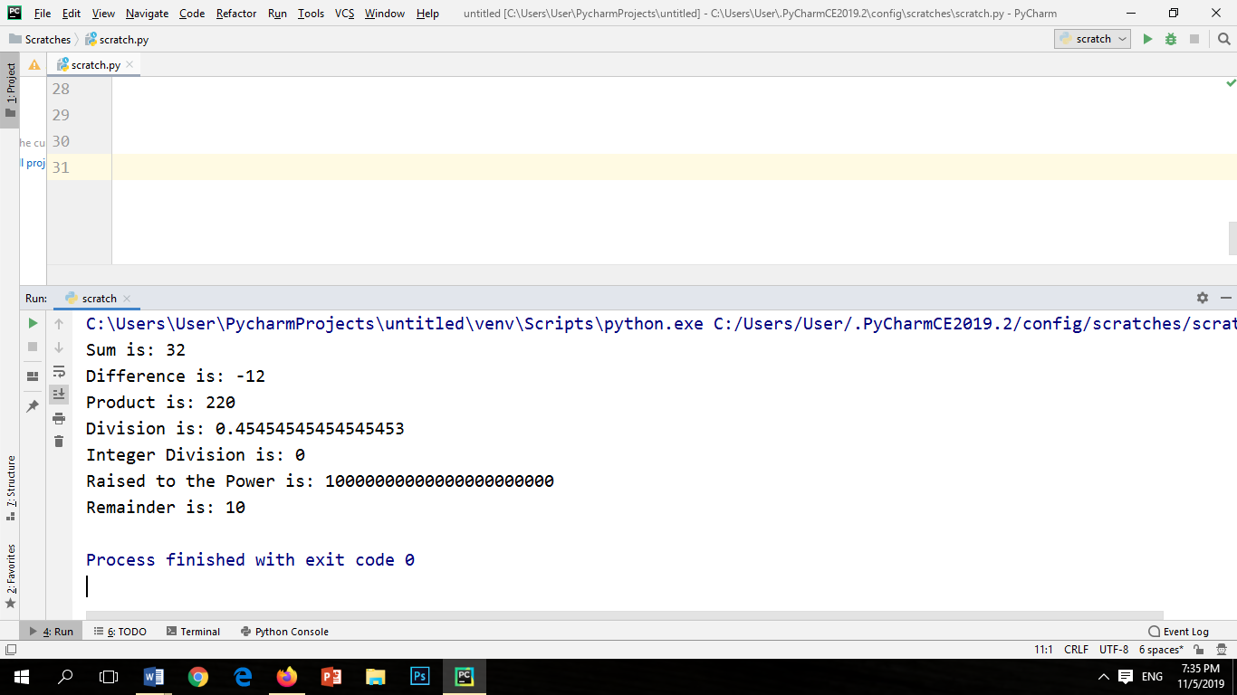

**Program#2** Write a program to use assignment operators**.**

CODE INPUT:

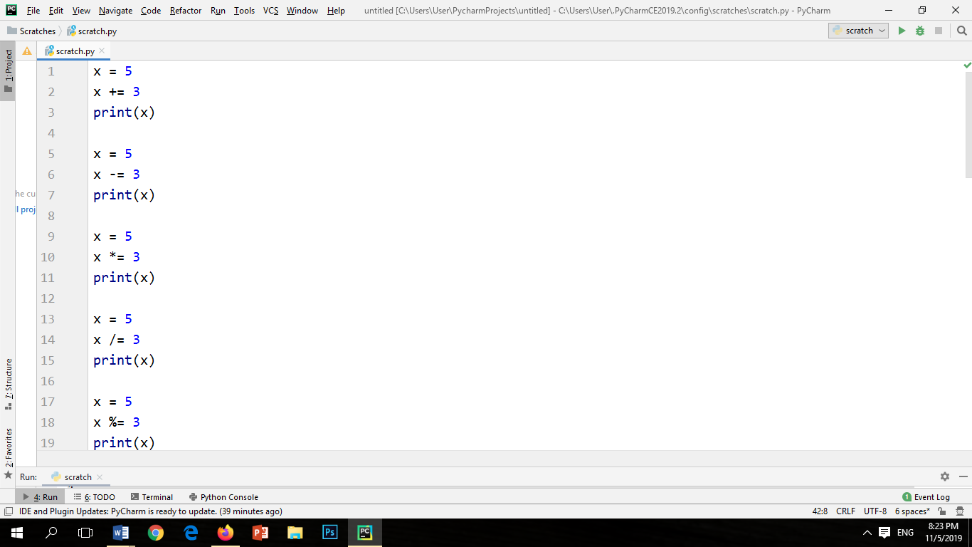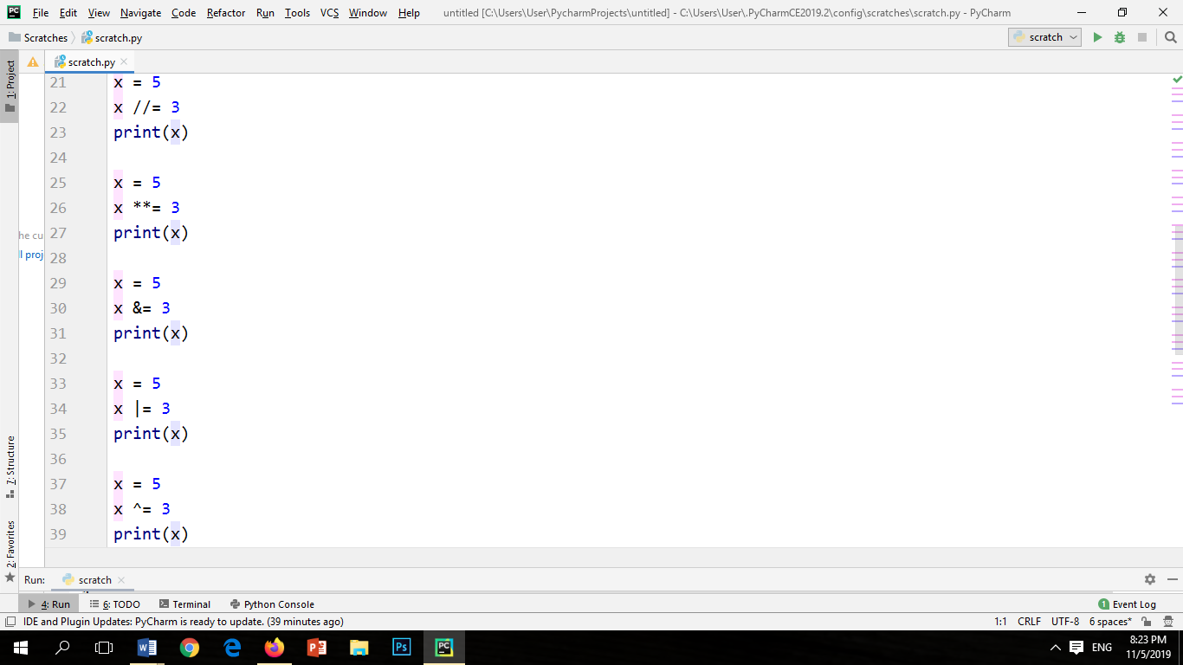

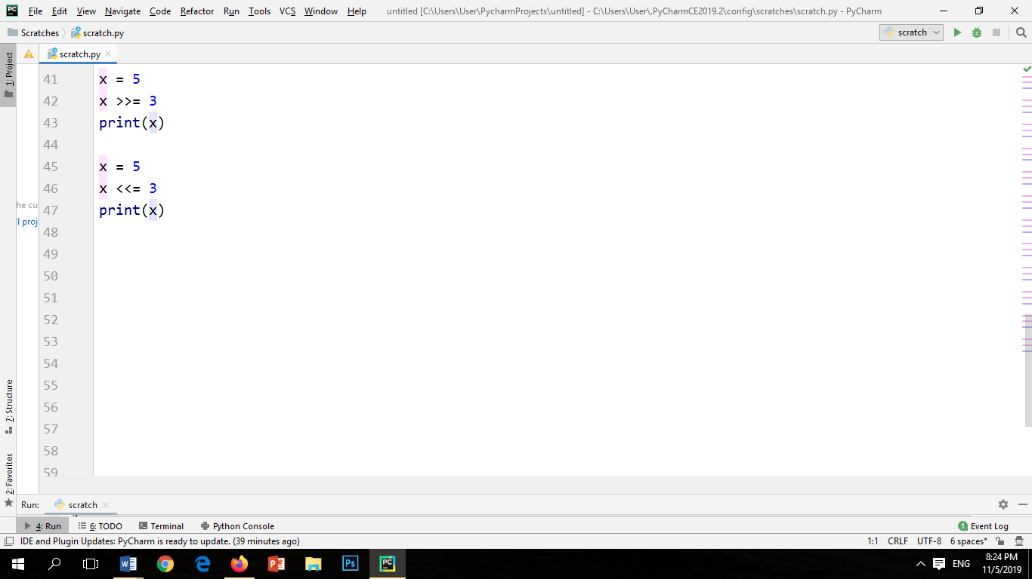

CODE OUTPUT: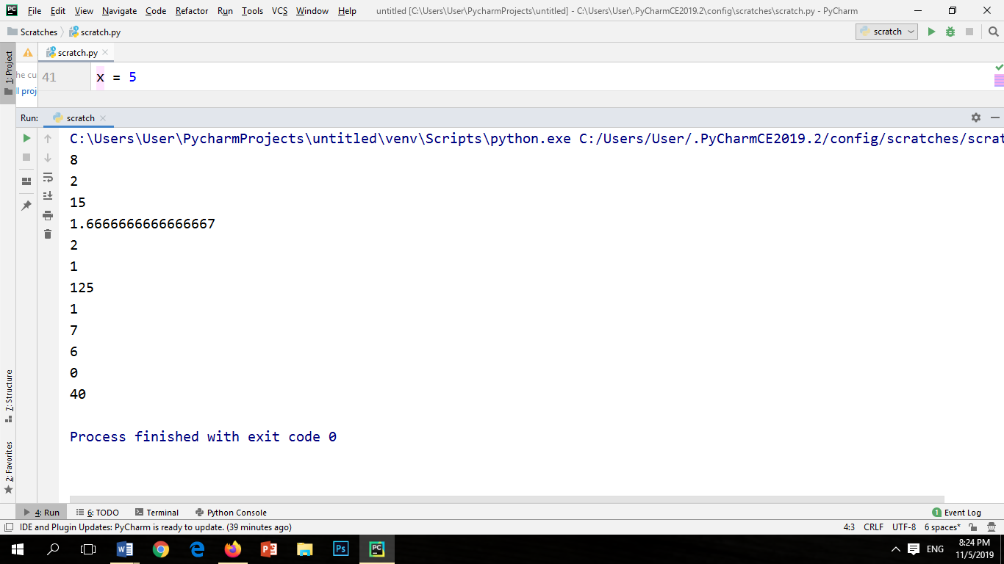

Program#3

Write a program to perform comparison operators.

CODE INPUT:

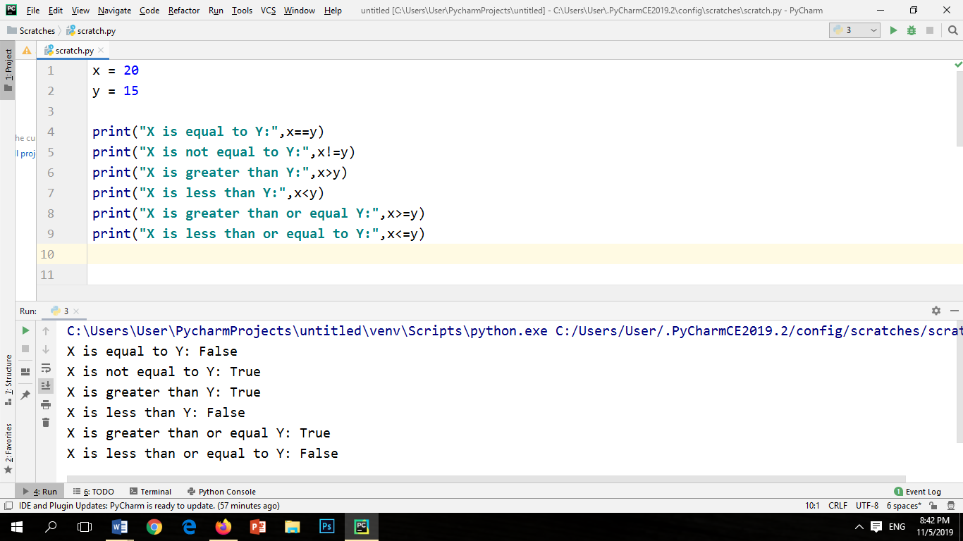

CODE OUTPUT:



Program#4

Write a program to perform logical operators.

INPUT:

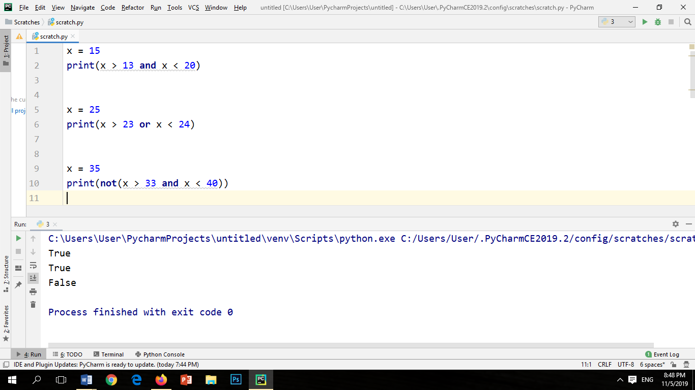

OUTPUT:



Program#5

Write a program to perform identity operator.

INPUT:

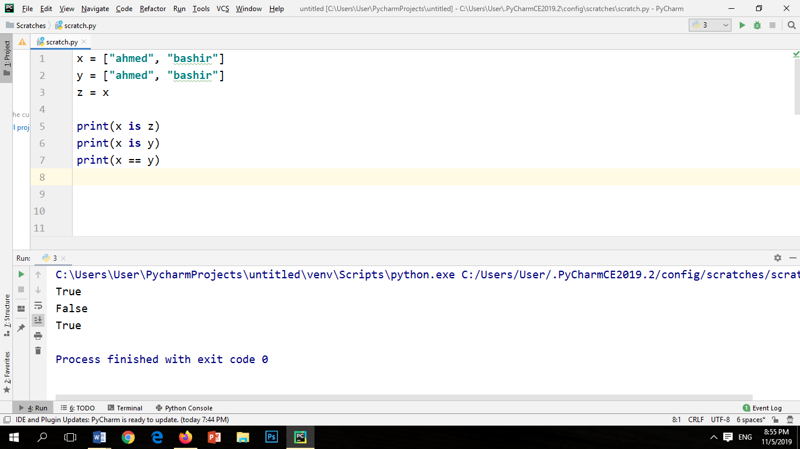

OUTPUT:



Program#6

Performing is not identity operation.

INPUT:

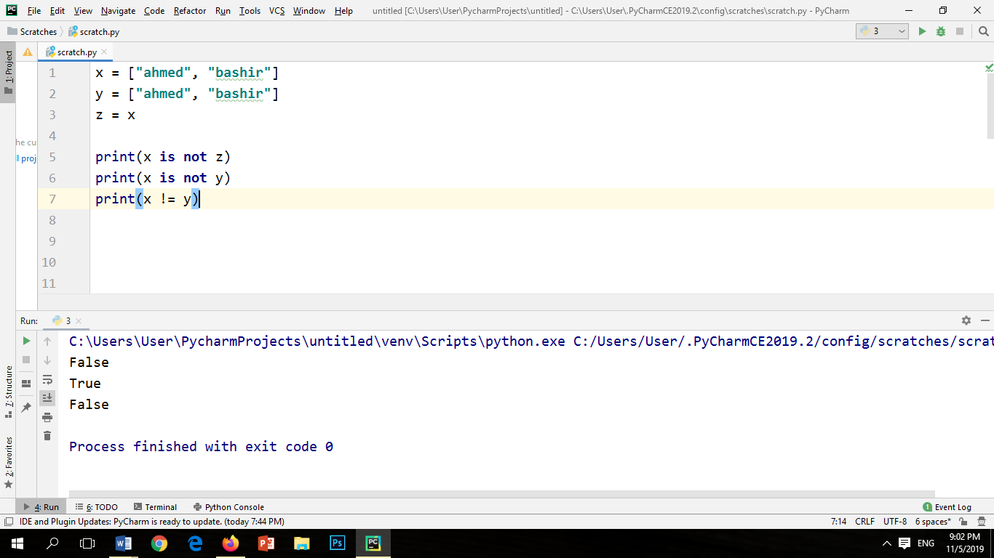

OUTPUT:



Program#7

Performing 'in' membership operation.

INPUT:

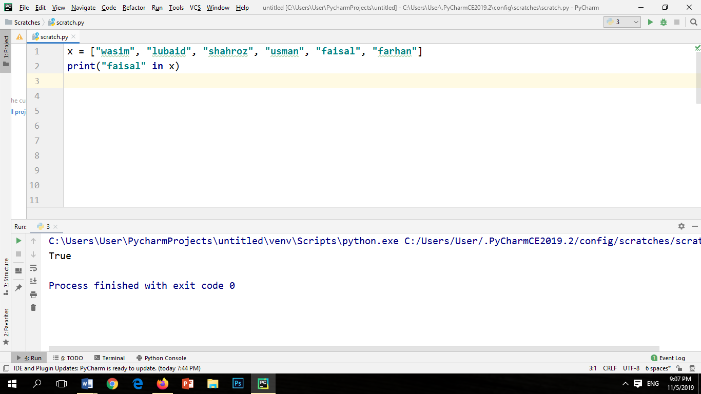

OUTPUT:



Program#8

Performing 'not in' membership operation.

INPUT:

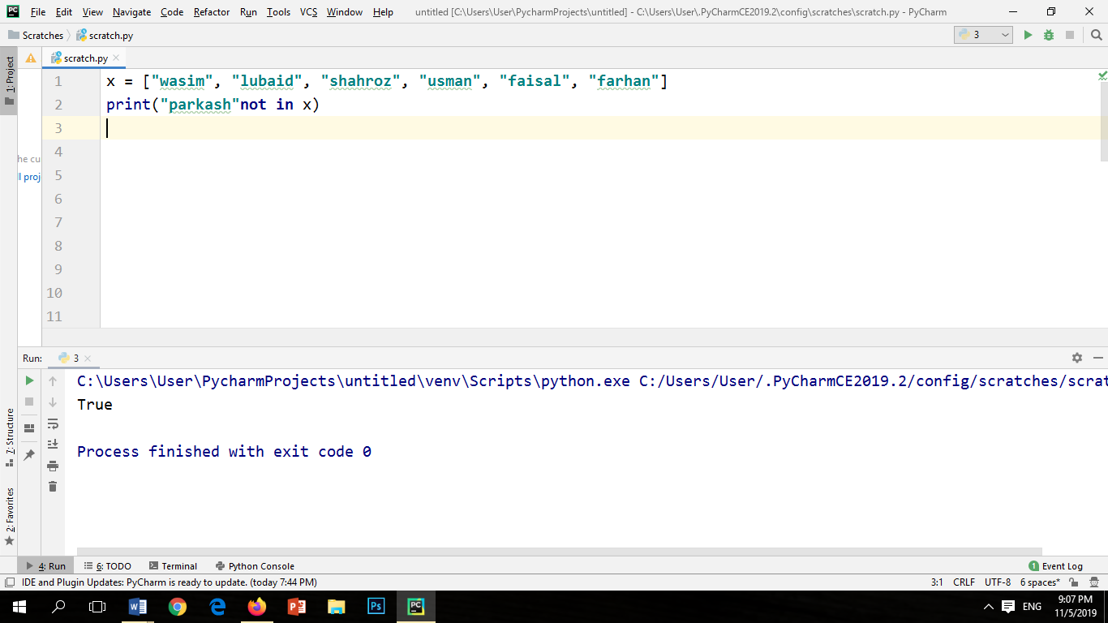

OUTPUT:



Program#9

You are planning to throw a small bird at a distance d, with time t, and height h to some structure. Write a code in which you will use the physical quantities such as initial velocity, final velocity, angle in radians, gravity, height, sling shot etc.

INPUT:

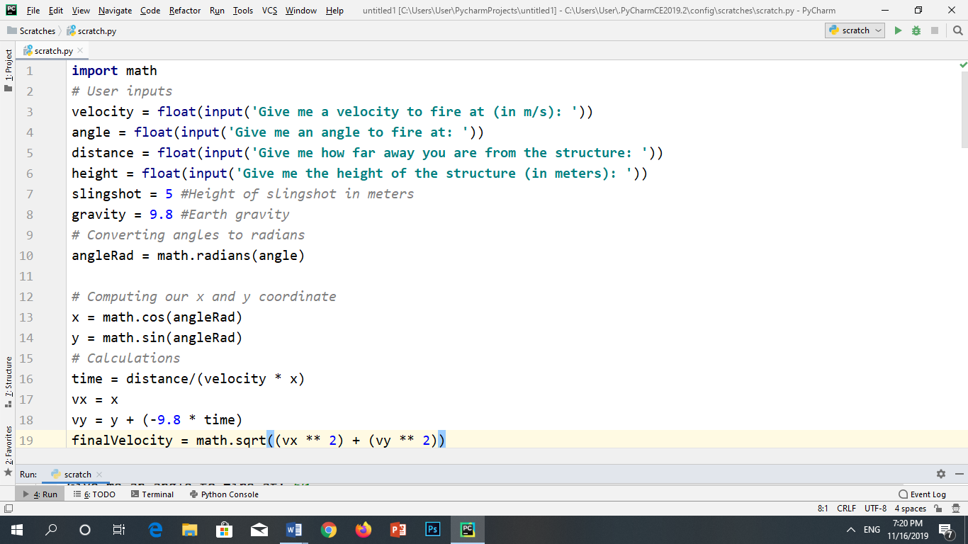

OUTPUT:

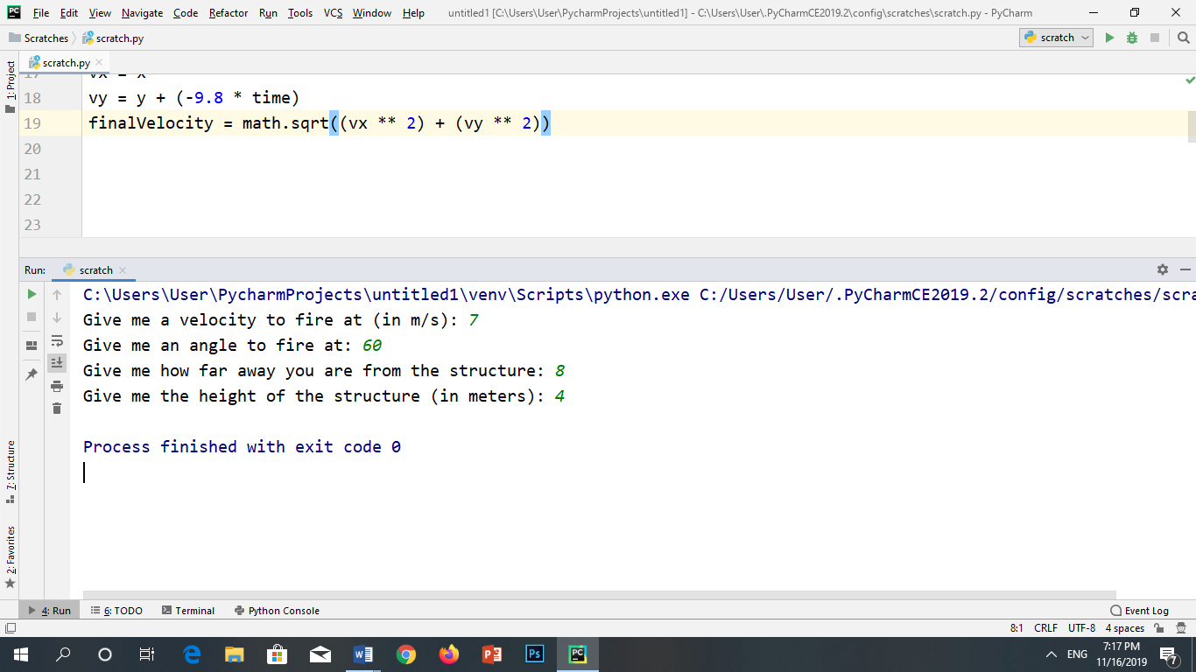

Programming Exercises

Question#1

A ball at the end of a string is revolving uniformly in a horizontal circle of radius 2 meters at constant angular speed 10 rad/s. Determine the magnitude of the linear velocity of a point located:

(a) 0.5 meters from the center

(b) 1 meter from the center

(c) 2 meters from the center

INPUT:

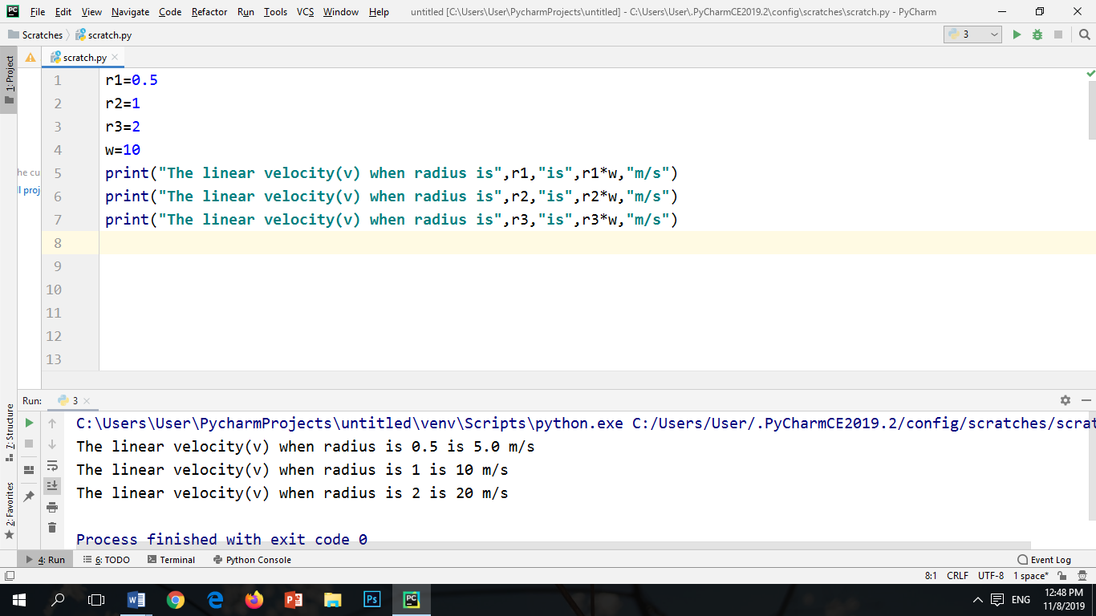

OUTPUT:



Question#2

The blades in a blender rotate at a rate of 5000 rpm. Determine the magnitude

Of the linear velocity:

(a) a point located 5 cm from the center

(b) a point located 10 cm from the center

INPUT:

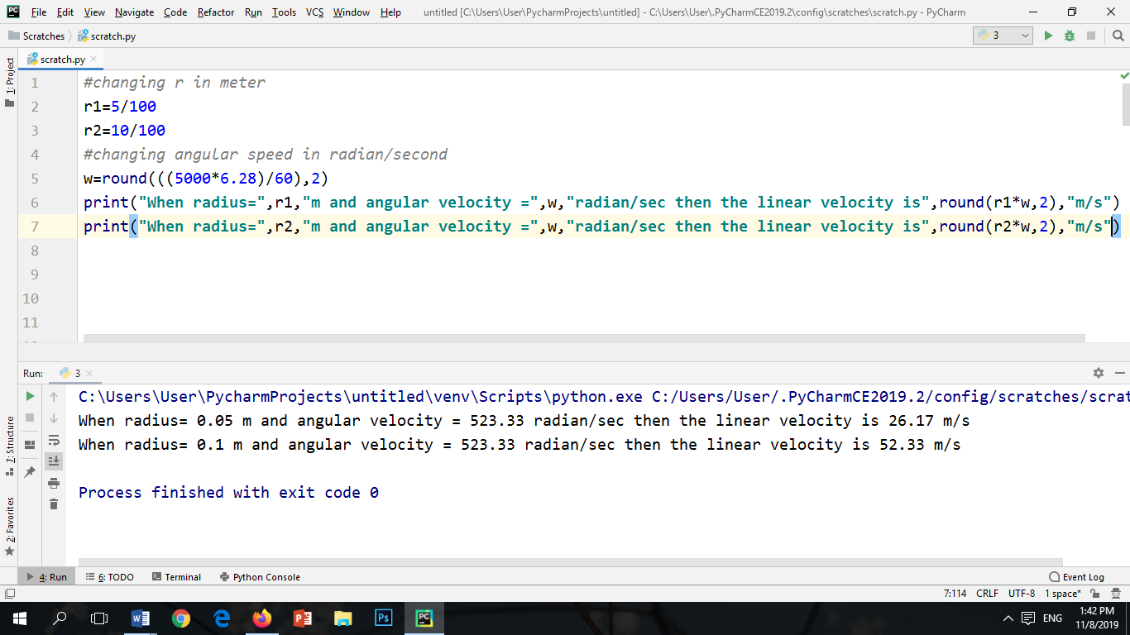

OUTPUT:



Question#3

A point on the edge of a wheel 30 cm in radius, around a circle at constant speed 10 meters/second. What is the magnitude of the angular velocity?

INPUT:

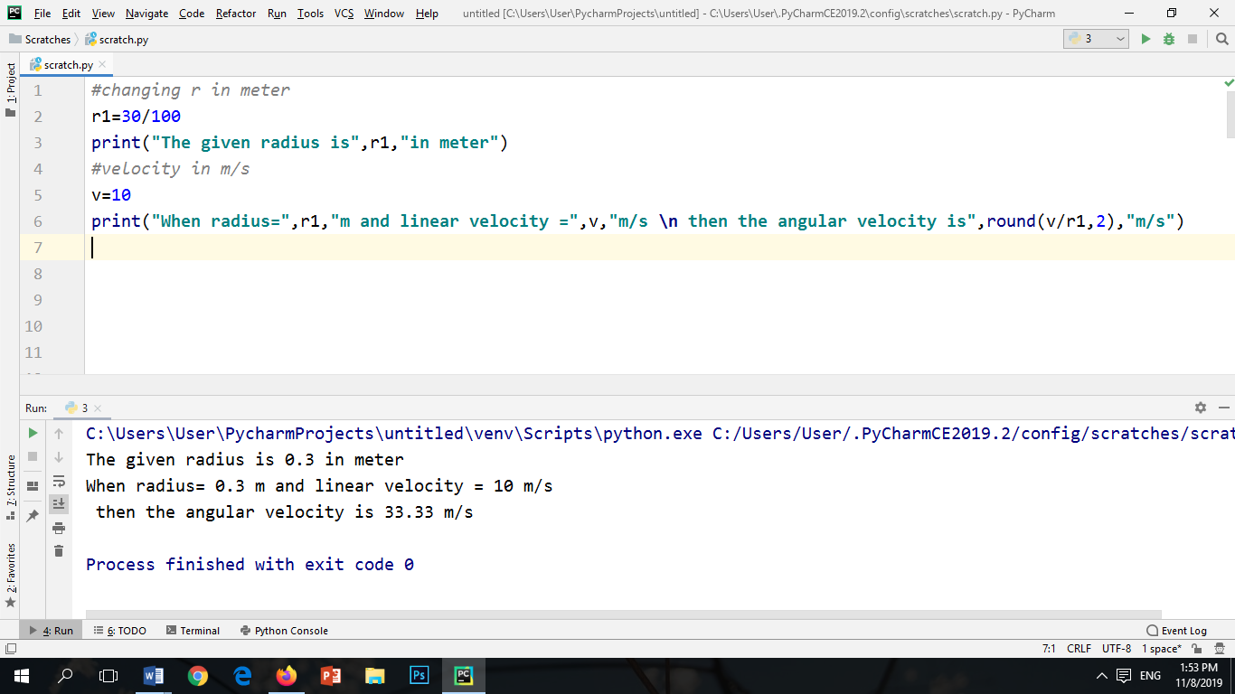

OUTPUT:



Question#4

A car with tires 50 cm in diameter travels 10 meters in 1 second. What is the

angular speed?

INPUT:

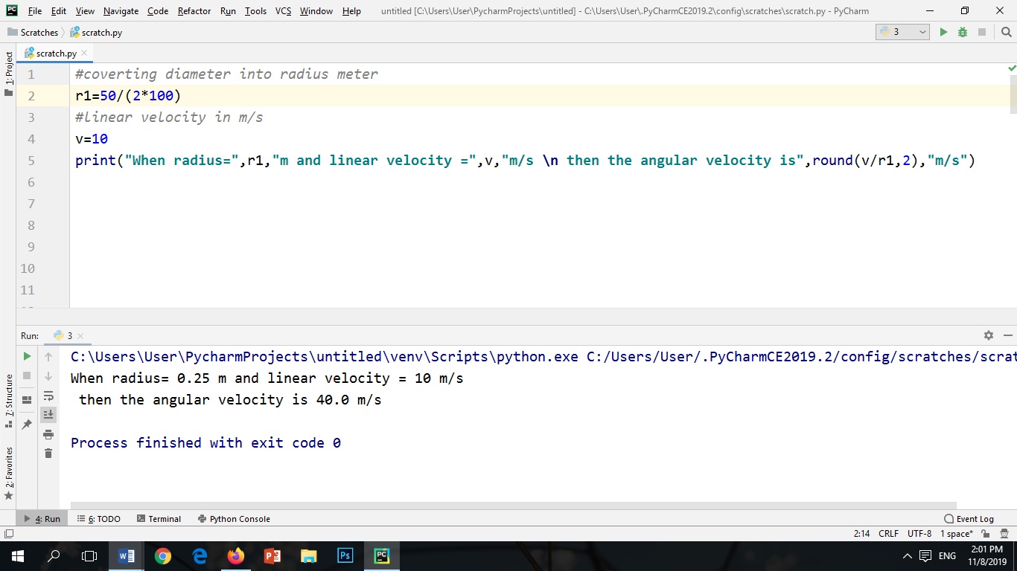

OUTPUT:



Question#5

The angular speed of wheel 20 cm in radians is 120 rpm. What is the distance if the car travels in 10 second.

INPUT:

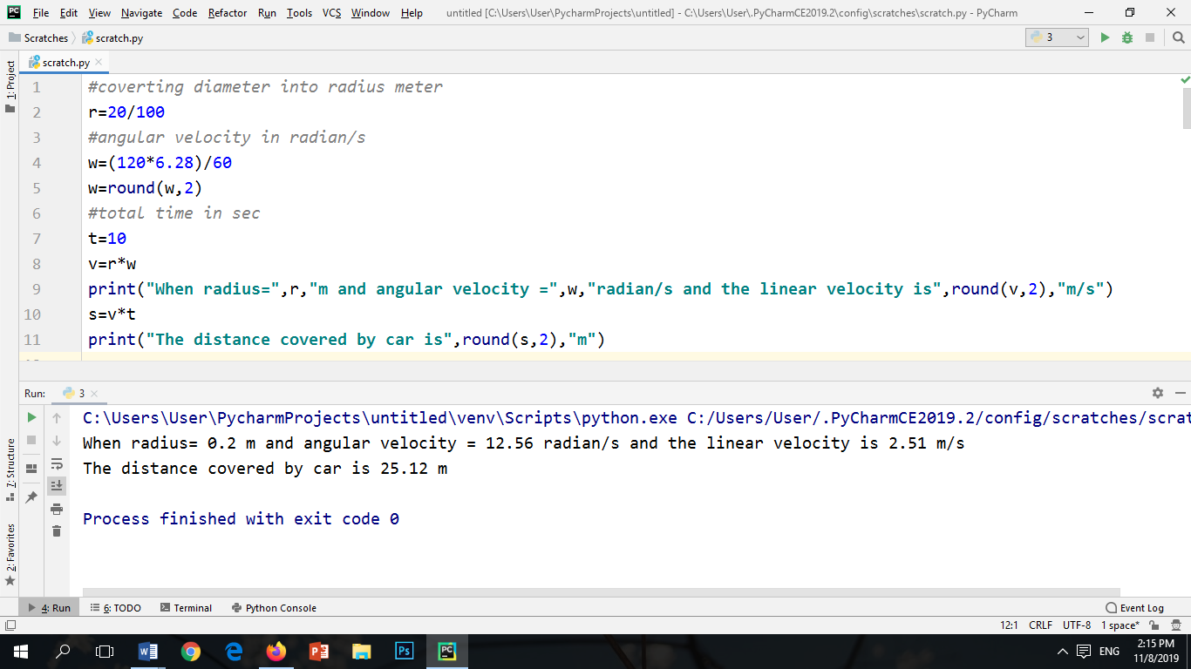

OUTPUT:



Question#6

A car is running at a velocity of 50 miles per hour and the driver accelerates the car by 10 miles/hr2. How far the car travels from this point in the next 2 hours if the acceleration is constant.

INPUT:

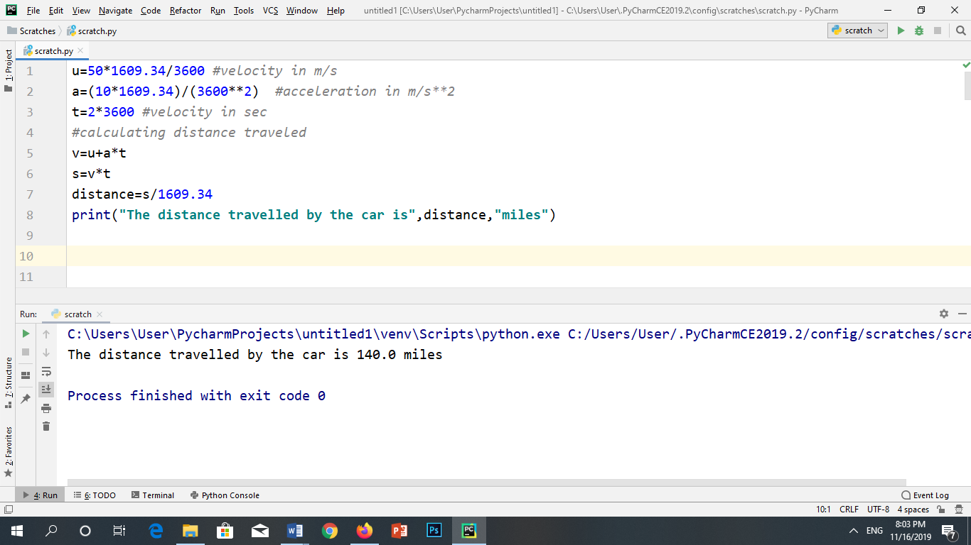

OUTPUT:



Question#7

A Stone is dropped freely from a height of 100 feet. With what velocity will it hit the ground? (Neglect the air resistance and assume the acceleration due to gravity is 32ft/s2). Formula: v2 – u2 = 2as

INPUT:

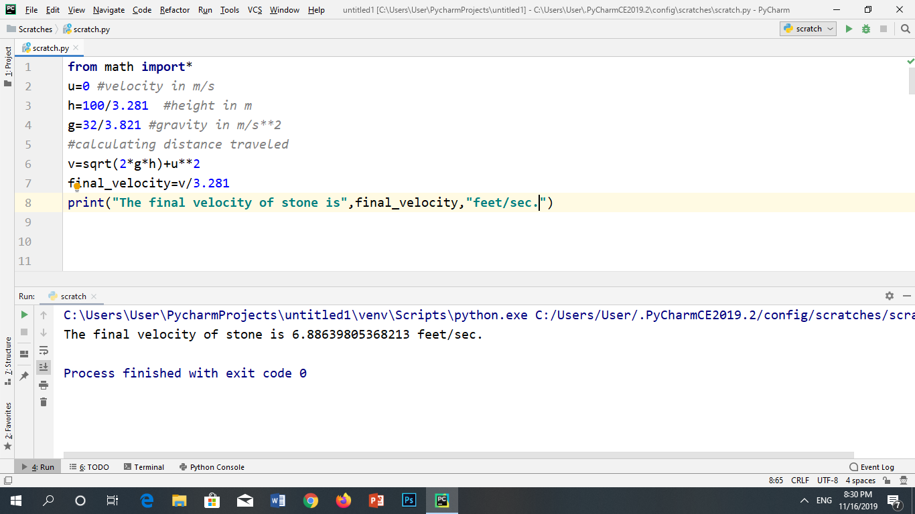

OUTPUT:

